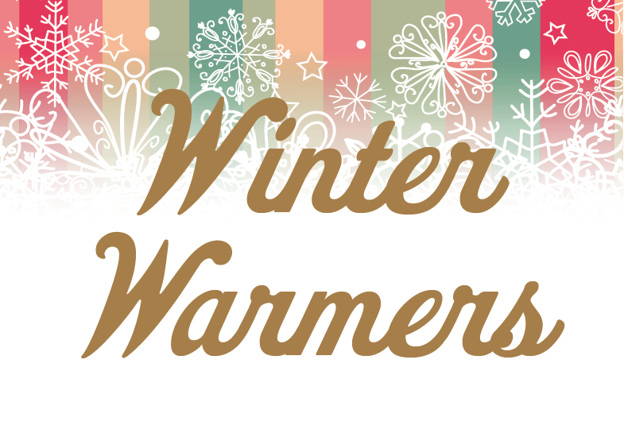

JAMESON’S HOT TODDY £4.50
Jameson’s Irish whiskey, honey, lemon and winter spices

BAILEYS LATTE £5.50
A large latte with a double Baileys

MULLED WINE glass £4.95 jug £15.95
Red wine, fresh orange and mixed winter spices

BAILEYS HOT CHOCOLATE £5.95
A large Cadburys hot chocolate with a double Baileys topped with cream and marshmallows

BAILEYS CARAMEL HOT CHOCOLATE £5.95
A large Cadburys hot chocolate with caramel syrup and a double Baileys topped with cream and marshmallows

JAMESON’S HOT CHOCOLATE £5.95
A large Cadburys hot chocolate with a shot of Jameson’s Irish whiskey topped with cream and marshmallows

WHY NOT HAVE A MINI MINCE PIE TO GET INTO THE SEASONAL MOOD

