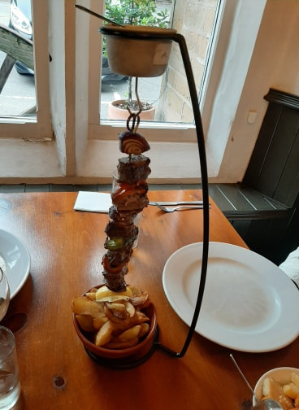
THE DRIZZLERS
Hanging kebabs with drizzling sauce for extra flavour
All Drizzlers are char grilled and served with your choice of side and a choice of drizzle

FILLET OF BEEF DRIZZLER £18.95
Prime beef fillet with fresh peppers and red onions

MIXED GRILL DRIZZLER £19.95
Prime beef fillet, marinated chicken breast, Cumberland sausage and gammon.

CHICKEN BREAST DRIZZLER £14.95
Marinated chicken breast peppers and red onions

KING PRAWN DRIZZLER £14.95
King prawns, peppers and red onions brushed with garlic butter

THE VEGAN DRIZZLER VE £10.95
red onions, peppers, corn on the cob and mushrooms brushed with soy and maple syrup

THE HALLOUMI DRIZZLER £11.95
Halloumi cheese with peppers and red onion.

Sides; (extra sides £2.00 each)
Fries with Mexican seasoning VE
Chunky wedged chips VE
Rice VE
Beef dripping roast potatoes
Roasted seasonal vegetables VE
Mac and cheese V

Drizzles:
Sweet chilli VE
Chilli and garlic butter V
Beef dripping sauce
Garlic butter V
Chilli butter V
THE DESSERT DRIZZLERS
SERVED OVER ICE CREAM
WITH A CHOCOLATE SAUCE OR BUTTERSCOTCH SAUCE DRIZZLE

WARM CHOCOLATE BROWNIE AND BELGIAN WAFFLE £8.95

TOASTED MARSHMALLOW £5.95

